**Abstract**

A System Analysis and Project Management project on Connecting riders with electric bike owners for convenient and sustainable commuting, fostering a community-driven approach to shared mobility  
Under the assistance of Prof. Srinivasan Raghunathan

Rent N’Glide

Electric scooter rental application

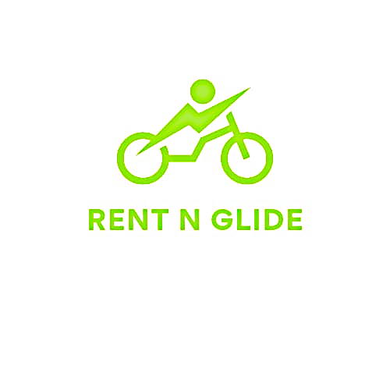

Adithya Kupparavalli Madhusudana

AXK220365@utdallas.edu

Hari Krishna Balamurali

HXB220038@utdallas.edu

Sai Siddaraju Poojitha

SXP220325@utdallas.edu

Contents

1. Executive Summary…………………………………………………………………………………....………….. 2

2. Problem Statement…………………………………………………………………….....………………………..2

3. Project Sponsor…………………………………………………………………………..……………………………3

4. Business need……………………………………………………………………………..……………………………3

5. Objectives……………………………………………………………………………….....……………………………3

6. Expected value..............................................................................................................4

7. Scope.............................................................................................................................4

8. BPMN (Business Process Model and Notation) model..................................................5

9. Context Diagram............................................................................................................6

10. Process Model

a. Use Case diagram..............................................................................6

b. Use Case Descriptions.......................................................................7

11. Data Model.................................................................................................................12

12. Object Behaviour Mode..............................................................................................14

* 1. 13. Functional Specification..............................................................................................15
  2. 14. Interface Design..........................................................................................................15
  3. 15. Complete Class Diagram.............................................................................................21
  4. 16. Database Design..........................................................................................................22
  5. 17. Software Design..........................................................................................................22
  6. 18. Project Timelines.........................................................................................................26
  7. 19. Project Minutes of Meeting.........................................................................................26

**Executive Summary**

The electric bike rental platform is designed to transform short distance commuting in urban areas, providing an eco-friendly, cost-effective, and convenient mode of transportation. Through a user-centric app/website interface, individuals can effortlessly locate, reserve, and access available electric bikes. The platform emphasizes safety, offers transparent battery management, encourages user feedback, and incentivizes efficient usage. Additionally, users have the option to list personal electric bikes, allowing them to earn while contributing to a sustainable urban transportation ecosystem.

The proposed project introduces a comprehensive set of features customized to enhance user experience and accessibility:

* Intuitive Rental Platform: A user-friendly app/website interface will be designed to enable easy bike location, rental, and unlocking, ensuring convenience for users.
* Secure Payment Integration: Integration of a robust and secure payment gateway within the platform for seamless rental payments, prioritizing user safety and convenience during transactions.
* Safety Measures: Implementation of safety instructions, guidelines, and user verification measures to ensure responsible and secure bike usage.
* Bike Availability Monitoring: Development of a system to monitor bike availability, allowing users to plan their rides effectively based on bike availability in specific locations.
* Feedback & Rating System: Incorporation of a feedback and rating system enabling users to provide feedback on their experiences, contributing to continuous service enhancement.
* Special Rewards for Usage Efficiency: Introduction of incentives for users in terms of reward points for the users demonstrating efficient and responsible usage patterns, encouraging sustainable commuting practices.
* Personal Bike Listing: Providing an option for users to register and list their personal bikes for rental, offering an additional revenue stream while expanding the platform's bike fleet.

This initiative draws upon the successful problem-solving methodology applied in past projects, aiming to deliver a user-centric bike rental platform that caters to the evolving needs of urban commuters, electric bike owners. Thus, ensuring sustainable, accessible, and cost-effective transportation solutions.

**Problem Statement**

In today's fast-paced world, individuals seek opportunities to expand their networks and skills, whether it's attending a professional networking event or enjoying a serene bike ride to escape the daily grind, or a daily commute in dense traffic. It is important to be on time irrespective of Traffic and other dependencies. Further, there are a lot of people living in Neighbourhood with Electric bikes or Kick scooters sitting Idle without proper utilization. Analyzing this situation of quick mobility and the expense of owning Electric bikes we came up with a solution for individuals which provides Quick transportation to their destination.

In the existing Rental system, there is one stakeholder who owns the Electric Bike Fleet and manages them through the station model. Which is expensive as it involves overhead expenses of Supply chain and maintenance and does not provide a facility to rent out personal electric bikes or Kick scooters for people. To address this issue, we came up with an Electric bike rental solution that allows customers to rent electric bikes for an affordable price as well as facilitates Bike owners to list their bikes and rent them out while they sit Idle.

“RentN’Glide” enables the ease of renting an electric bike. Once an owner registers their bike on our page it will be available for nearby customers and help them connect, Further rent their electric bike based on the availability and Rent.

**Objectives**

* Seamless User Experience: Develop an intuitive website interface allowing users to easily locate and rent bikes, ensuring a user-centric and accessible experience for both renters and bike owners.
* Real-Time Availability Monitoring: Establish a system to monitor bike availability in specific locations, enabling efficient ride planning for renters while encouraging bike owners to list their available bikes for rental.
* Continuous Improvement & Feedback Loop: Implement a feedback and rating system enabling users to share experiences and suggestions, facilitating continuous service enhancement based on user insights, and ensuring a responsive platform.
* Promotion of Sustainable Commuting: Encourage eco-friendly practices by incentivizing efficient and responsible bike usage patterns, promoting sustainable urban mobility while offering additional earning opportunities for bike owners.
* Community Engagement & Diversity in Offerings: Cultivate a sense of community by enabling bike owners to contribute to shared urban mobility, diversifying the platform's bike fleet to cater to varied user preferences, and enhancing the overall biking experience.

These objectives aim to create an integrated platform that not only provides convenient and secure bike rentals but also empowers bike owners to contribute to a sustainable and diverse urban transportation ecosystem while earning additional income.

**Scope - Special issues or constraints**

**Enhancing City Travel Experience:** We're creating a bike rental service to make city travel easier. This helps when public transport isn't great or when rides are too costly.

**Complete Commuting Solution**: Our plan isn't just about renting bikes for a short time. It's also about letting people share their bikes. This way, everyone can find a way to get around the city that suits them.

**Focused on Dallas, Texas:** We're starting in Dallas because transport options here need a boost as there is heavy wait time in public transportation. We want to help a lot of different people who struggle to find good transport.

**Project Plan:** We're estimating 5 months for project completion which includes all stages of Requirement analysis, development, testing and final deliverables. We'll listen to feedback and make things better as we go along.

**Making Connections Easy:** We're making it quick and easy for people to find bikes or find someone to rent their bike too. This way, everyone gets around faster and easier.

**Check if It Works:** We're checking if this idea makes sense and if it'll work well. We're also thinking of ways to make money from this idea.

**Working Together for Better Travel:** By getting bike owners involved, we're creating a community where everyone can help each other travel easily. It's about making city travel better and giving bike owners a chance to earn extra.

**Business Process Model and Notation**

The following diagram showcases the BPMN representation for the Rent N’Glide rental system.

**Context Diagram**

The context diagram below outlines the interactions between Rent N’Glide system and other factors (Owners, Customers and Map) with which the system is designed and gives the overall functionality of the proposed system.



Rental Payment

List a bike

Google

Owner

RentN’ Glide

Customer Registration

Search for Bike Rental

Rent a Bike

Customer

Process Payment

Return/Drop off Bike

Owner Registration

Customer Feedback

owner feedback

Rewards

Finding nearest Bike location

Google Location request

**Use Case Diagram**

A use case diagram visually represents the potential interactions between users and a system. The following diagram showcases the BPMN representation for the Rent N’Glide rental system.

**Use Case Description**

|  |
| --- |
| **Use Case Description 1:** |
| Use Case Name: Search for a rental Bike |
| Primary Actor: Customer |
| Stakeholders: Scooter owners/App owners |
| Brief Description: Available electric scooter within the customer-given range |
| Trigger: Customer searches by clicking the search button |
| The normal flow of events:  1. Customer is logged into the RentN’Glide website.  2. Customer searches for an event they wish to attend.  3. Search engine responds to the customer. |

|  |
| --- |
| **Use Case Description 2:** |
| Use Case Name: Google location request |
| Primary Actor: Customer |
| Stakeholders: Third party |
| Brief Description: fetches the current location of the customer. |
| Trigger: Customer selects allow in “Do you want to share current location” popup |
| The normal flow of events:   1. Customer selects allow for the ‘Do you want to share current location’ pop-up. 2. Customers current location coordinates gets stored in the customer database. |

|  |
| --- |
| **Use Case Description 3:** |
| Use Case Name: Bike owner registration |
| Primary Actor: Bike owner |
| Stakeholders: App owners |
| Brief Description: Facilitates bike owner to register and list the bikes for rental on the platform |
| Trigger: Bike owner selects “Register as bike owner” option in the app. |
| The normal flow of events:   1. Bike owner accesses the bike rental app and opts for owner registration. 2. Owner provides personal information, bike details, and rental terms. 3. System verifies the provided details and creates a bike owner account. 4. System prompts the owner to list bikes for rental after successful registration. 5. Bike owner lists bikes, specifying availability and rental terms. 6. System confirms successful registration as a bike owner. |
| **Use Case Description 4:** |
| Use Case Name: Customer registration |
| Primary Actor: New customer |
| Stakeholders: App owners |
| Brief Description: Allows new customer to create an account for accessing bike rental. |
| Trigger: New user selects “Register” or “Sign-up” option in the app. |
| The normal flow of events:   1. New customer opens the bike rental app and initiates the registration process. 2. Customer enters personal details such as name, email, and password. 3. System validates the information and creates a customer account. 4. System sends a verification email or confirmation to the user. 5. Customer verifies the account via email link or confirmation code. 6. System confirms successful registration and grants access to the app functionalities. |

|  |
| --- |
| **Use Case Description 5:** |
| Use Case Name: List Bike for rental |
| Primary Actor: Bike owner |
| Stakeholders: Customer / App owners |
| Brief Description: Allows bike owners to list their bikes for rental on the platform |
| Trigger: Bike owner selects “LIST BIKE FOR RENTAL” option in the app |
| The normal flow of events:   1. The bike owner logs into the bike rental app. 2. Bike owner provides details and availability of their bikes. 3. The system verifies and lists the bike for potential rentals. |

|  |
| --- |
| **Use Case Description 6:** |
| Use Case Name: Rent a Bike |
| Primary Actor: Customer |
| Stakeholders: Bike owner, payment gateway system |
| Brief Description: Enables customers to rent a bike from the available options. |
| Trigger: when a customer selects “RENT A BIKE” option for a specific bike. |
| The normal flow of events:   1. Customer selects a bike from the available list. 2. Customers confirm the rental and duration. 3. The system processes the payment through the payment gateway. 4. The system notifies the bike owner and provides rental details to the customer. |

|  |
| --- |
| **Use Case Description 7:** |
| Use Case Name: Process Rental payment |
| Primary Actor: Customer |
| Stakeholders: Payment gateway services/App owners |
| Brief Description: Handles a payment process for renting a bike |
| Trigger: Customer confirms the rental and initiates the payment |
| The normal flow of events:   1. Customer selects bike for rental and confirms the rental duration. 2. The system calculates the rental fee and prompts the customer to proceed with payment. 3. Customer provides payment details and authorizes the transaction. 4. The system processes the payment through the integrated payment Gateway. 5. Payment gateway confirms successful transaction and updates |

|  |
| --- |
| **Use Case Description 8:** |
| Use Case Name: Return/Drop off Bike |
| Primary Actor: Customer |
| Stakeholders: Bike owners/ App owners |
| Brief Description: Manages the process for returning or Dropping off the rented bike |
| Trigger: Customer completes the rental duration or decides to return the bike earlier. |
| The normal flow of events:   1. Customer reaches the designated return or drop-off point or rental endpoint. 2. Customer notifies the system through the app about returning the bike. 3. System confirms the return request and updates the rental status. 4. Bike owner or App owner verifies the Bike's condition upon return. 5. System finalises the rental, calculates additional fee (If applicable), & ends the rental session. |

|  |  |
| --- | --- |
| **Use Case Description 9:** | |
| Use Case Name: Customer feedback | |
| Primary Actor: Customer | |
| Stakeholders: Bike owners/ App owners | |
| Brief Description: Allows customers to give feedback on the issues or damages to the bike | |
| Trigger: Customers provide feedback through the app | |
| The normal flow of events:   1. Customer identifies the issues with the rented bike. 2. Customer notifies the system by submitting detailed feedback. 3. The system flags a bike for inspection and notifies the owner. | |
| **Use Case Description 10:** |
| Use Case Name: Rewards for Efficient Bike Usage. |
| Primary Actor: Customer |
| Stakeholders: Bike owners/ App owners |
| Brief Description: Reward points for users demonstrating efficient and responsible usage patterns with rewards within the platform |
| Trigger: Customer completes a rental transaction with faultless usage behavior. |
| The normal flow of events:   1. Customer logs into the bike rental platform and completes a rental transaction. 2. During the rental period, the system monitors usage behavior based on predefined criteria (e.g., timely return, and careful handling). 3. Upon the completion of the rental, if the customer's behavior aligns with the efficient usage criteria, the system acknowledges the exemplary behavior. 4. The system awards the customer with rewards, which could include loyalty points and discounts on future rentals. 5. The customer receives notification or acknowledgment of the rewards earned for their efficient usage. 6. The system updates the customer’s profile with the awarded rewards. |

**Data Model**

The diagram below illustrates the proposed system's class diagram, derived from a data dictionary but excluding methods.



**Data Dictionary**

**Use Case 1 – Search for a rental Bike.**

Login = Customer user ID + Customer password

Search for a bike = [Bike Name | Location | Owner]

Customer user ID = email address

Password = data element

**Use Case 2 – Google location request.**

Location Permission = [Yes | No]

Current Coordinates = Latitude + Longitude

**Use Case 3 – Bike owner registration.**

Owner Data = [Owner Name + Owner Email id + Owner Phone number]

Owner Address = [owner address + State + City + Zipcode]

Payment Information = [Payment method + Rent amount ]

**Use Case 4 – Customer Registration.**

Customer Data = [Customer Name + Customer Email id + Customer Phone number]

Customer Address = [Customer address + State + City + Zip code]

Payment Information = [Payment method + Rent amount]

**Use Case 5 – List Bike for rental.**

Owner Data = [Owner Name + Owner Email id + Owner Phone number]

Bike Data = [ Bike name + Availability + Rent amount]

**Use Case 6 – Rent a Bike.**

Owner Data = [Owner Name + Owner Email id + Owner Phone number]

Customer Data = [Customer Name + Customer Email id + Customer Phone number]

Bike Data = [ Bike name + Rent amount + Bike location]

**Use Case 7 – Process Rental payment**.

Payment Information = [Payment method + Rent amount]

Payment Confirmation = [Yes|No]

**Use Case 8 – Return/Drop off Bike**.

Return = [Yes|no]

Customer Data = [Customer Name + Customer Email id + Customer Phone number]

Owner Data = [Owner Name + Owner Email id + Owner Phone number]

Location = [Return location]

Additional Rent = [Yes|No|Amount]

**Use Case 9 – Customer feedback.**

Customer Data = [Customer Name + Customer Email id + Customer Phone number]

Owner Data = [Owner Name + Owner Email id + Owner Phone number]

Bike Data = [ Bike name ]

Feedback = [Yes|No|Feedback text|Bike rating]

**Use Case 10 – Rewards for Efficient Bike Usage.**

Customer Data = [Customer Name + Customer Email id + Customer Phone number]

Rent Data = [Rent duration + Utilization + Damage + Drop location + Owners Feedback]

Rewards = [Yes | No | Reward Type]

**Sequence Diagram** (**Object behaviour model)**

A sequence diagram is a Unified Modeling Language (UML) diagram that illustrates the sequence of messages between objects in an interaction. The below diagram depicts the sequence diagram for the proposed diagram.

**Functional Specifications**

* RentN'Glide, a revolutionary platform dedicated to facilitating affordable and convenient electric bike rentals, connecting bike owners with those in need of a sustainable and cost-effective mode of transportation.
* Provides an integrated platform that not only provides convenient and secure bike rentals but also empowers bike owners to contribute to a sustainable and diverse urban transportation ecosystem while earning additional income.
* Allows electric bike owners to share their bikes and earn extra income. By connecting individuals seeking affordable transportation with those willing to rent out their electric bikes, our platform transforms commuting into a collaborative and sustainable community experience.
* Feedback and rating system enabling users to share experiences and suggestions, facilitating continuous service enhancement based on user insights, and ensuring a responsive platform.

**Interface Design**

A prototype with 8 frames was developed to showcase our proposed system. The flow includes Owner registration, Bike listing, Customer registration, Bike renting, Payment page, and Feedback page.

**Frame:** When a new Bike owner or Customer visits Rent N’Glide for the first time they will be provided with the following options to proceed with registering to the application.



**Get Started as Owner**

**Get Started as Customer**

**Frame:** If the user selects Register as the owner, then the following screen appears where he will be asked to populate the necessary registration details.

**Frame:** Once owner registration is completed then he/she needs to list their bike in Rent N’ Glide application so that their bike is visible to customers.

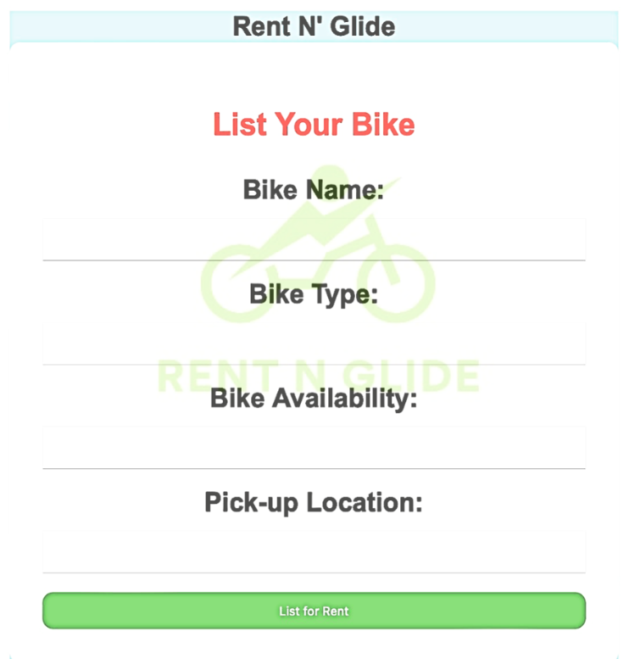

**Frame:** If the user selects Register as a customer, then the following screen appears where he will be asked to populate the necessary registration details.

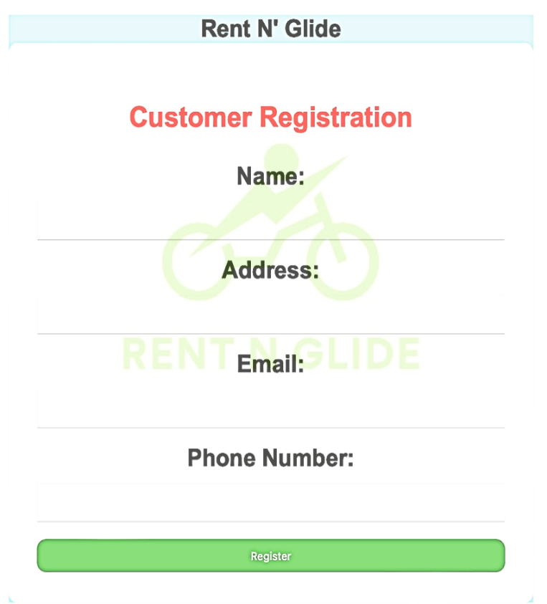

**Frame:** Once the customer is registered, he will be enabled to search and rent electric bikes that are available in the specified location/area.

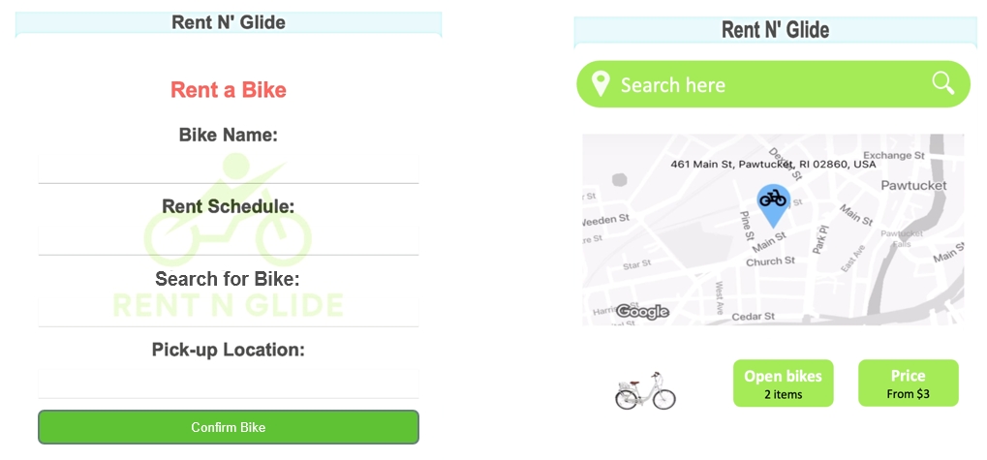

**Frame:** Once a customer selects the bike of their liking, they will be redirected to the payment gateway to proceed with payment.

**Frame:** Once the customer finishes their ride he should Return/drop the bike at specific drop off location, and complete the ride with any applicable penalty

**Frame:** Once the customer drops the bike and completes the entire transaction then he will receive a Feedback page where his/her valuable feedback is recorded for future reference and improvements to Rent N’ Glide

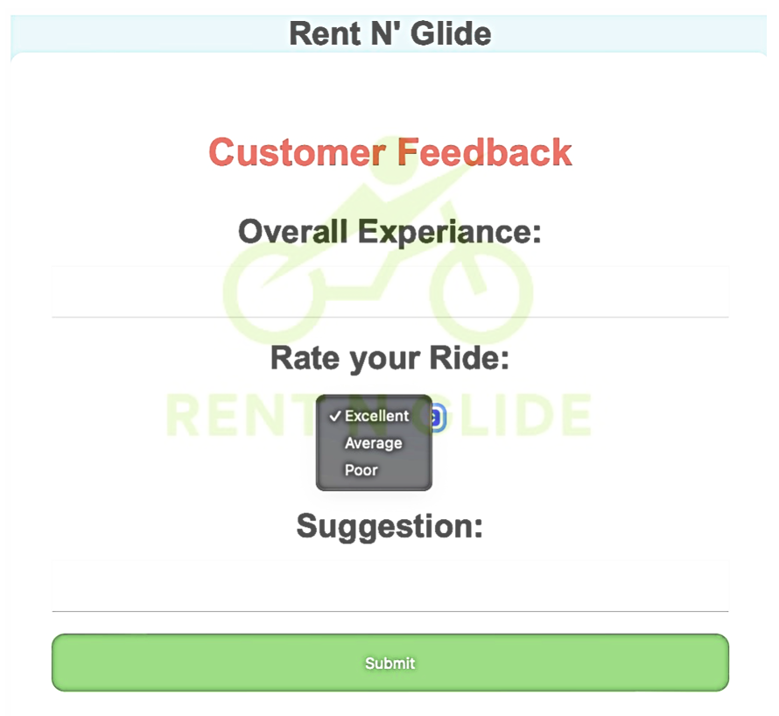

**Database Design**

**Complete class diagram**



**Software Design**

Software design is a process of transforming user requirements into some suitable form, which helps the programmer in software coding and implementation. As such, we designed the software with the respective pseudo code for the five following methods: ‘Customer Registration’, ‘Rent bike’, ‘Bike location’, ‘Customer Location’, and ‘Reward Points’.

**Method Name: Owner Registration ()**

**Class Name:** OwnerRegistration

**Clients (Consumers):** New Bike Renter

**Associate Use Cases:** Onboarding new owners onto the bike rental platform

**Description of Responsibilities:** Enable Owners to register their bike for rental services

**Arguments Received:** Owner’s registration details (Name, Contact, Address)

**Type of Value Returned:** Registration Confirmation

**Logic:**

**RECEIVE Owner's Registration Details:**

COLLECT the owner's personal information (Name, Contact, Address).

**VALIDATE Owner Information:**

VERIFY the provided details for completeness and accuracy.

**CREATE Owner Account:**

STORE the validated owner information in the system database.

**CONFIRM Registration:**

DISPLAY a confirmation message: "Registration successful!

Welcome to the Rent N’Glide".

**Method Name: Bike Listing ()**

**Class Name:** List_a_bike

**Clients (Consumers):** New Bike listing

**Associate Use Cases:** Adding new bike to rent for Customers

**Description of Responsibilities:** Enable Owners to register their bike for rental services.

**Arguments Received:** Bike details (Bike Name, Bike Type,Bike location, Availablity)

**Type of Value Returned:** Listing confirmation

**Logic:**

**RECEIVE Bike Details:**

COLLECT Bike Details (Bike Name, Bike Type, Bike Location, Availablity).

**VALIDATE Bike Information:**

VERIFY the provided details for completeness and accuracy.

**CREATE Bike Listing:**

STORE the validated Bike information in the system database.

**CONFIRM Listing:**

DISPLAY a confirmation message: "Listing successful! “

**Method Name: Customer Registration ()**

**Class Name:** CustomerRegistration

**Clients (Consumers):** New Bike Renter

**Associate Use Cases:** Onboarding new users onto the bike rental platform

**Description of Responsibilities:** Enable users to register for bike rental services

**Arguments Received:** User's registration details (Name, Contact, Address)

**Type of Value Returned:** Registration Confirmation

**Logic:**

**RECEIVE User's Registration Details:**

COLLECT the user's personal information (Name, Contact, Address).

**VALIDATE User Information:**

VERIFY the provided details for completeness and accuracy.

**CREATE User Account:**

STORE the validated user information in the system database.

**CONFIRM Registration:**

DISPLAY a confirmation message: "Registration successful!

Welcome to the Rent N’Glide".

**Method Name: Rent Bike()**

**Class Name:** BikeRental

**Clients (Consumers):** Bike Renter

**Associate Use Cases:** Bike renting process

**Description of Responsibilities:** Facilitate the bike rental process for customers

**Arguments Received:** User request to rent a bike

**Type of Value Returned:** Bike Rental Status

**Logic:**

**CHECK Bike Availability:**

VERIFY if the requested bike is available for rental.

**IF Bike Available THEN:**

ASSIGN the bike to the requesting user for rental.

SET the bike status as "Rented" in the system.

UPDATE Rental Status: "Bike successfully rented by Customer X."

**ELSE:**

DISPLAY a message: "Bike is currently unavailable. Please try another bike."

**Method Name: ProcessPayment()**

**Class Name:** PaymentProcessor

**Clients (Consumers):** Customers making bike rental payments

**Associate Use Cases:** Facilitating payment for bike rental services

**Description of Responsibilities:** Enable users to make secure payments for bike rentals

**Arguments Received:** Payment details (Payment type, Amount, Transaction ID)

**Type of Value Returned:** Payment Confirmation

**Logic:**

**RECEIVE Payment Details**:

COLLECT the user's payment information (Card details, Amount, Billing Address).

**VALIDATE Payment Information:**

ENSURE the completeness and accuracy of the provided payment details.

**AUTHORIZE Payment:**

VERIFY card authenticity and availability of funds for the transaction.

**PROCESS Payment Transaction:**

TRANSFER the specified amount from the user's account to the rental platform.

GENERATE a unique transaction ID for record-keeping.

**CONFIRM Payment:**

DISPLAY a confirmation message: "Payment successful!

Your bike rental is now confirmed."

**Weekly Project Timeline**

|  |  |  |
| --- | --- | --- |
| Weekly Schedule | | Task |
| 4th Sep | 10th Sep | Self-introductions within the team, Exchange email IDs, Exchange phone numbers |
| 18th Sep | 24th Sep | Get to know the team, Discuss new ideas and topics for the project |
| 25th Sep | 1st Oct | Project Idea brainstorming, the team brainstormed the domain on which we would be pitching ideas. |
| 2nd Oct | 8th Oct | Finalized on "Rent N’ Glide" |
| 9th Oct | 15th Oct | Documentation of problem and proposed idea, Design Context Diagram, Identify actors and processes, |
| 16th Oct | 22nd Oct | Design a Use-case Diagram and Process diagram, Write Use-case description and data dictionary, Design class diagrams. |
| 30th Oct | 5th Nov | Sequence diagrams, Design database diagrams, Identify database constraints |
| 6th Nov | 12th Nov | Data Model, Object Behavior Model, Documentation of methods |
| 13th Nov | 19th Nov | Logic Design, Database Design, Software Design |
| 20th Nov | 26th Nov | Complete Class Diagram, HTML Mockup, Report documentation |
| 4th Dec | 8th Dec | Proof-read and presentation preparation,  Final report submission |

**Project Minutes of Meeting**

|  |  |  |
| --- | --- | --- |
| Meeting Week | 4th – 10th September | |
| Meeting Type | MIS 6308.0W2 | Project Group 22: Weekly Touchpoint |
| Attendees | Hari Krishna Balamurali, Adithya Kupparavalli Madhusudhana, Sai Siddaraju Poojitha | |
| Topic Discussed | Team Introductions | |
| Meeting Minutes   * Self-introductions within the team * Exchange email ID, * Exchange phone numbers | | |
| Conclusion | | |
| Action Items | Responsibility | Due Date |
| Hari Krishna Balamurali | Self-Introductions within the team, Exchange email ID, Exchange phone numbers | 10th September |
| Adithya Kuppravalli Madhusudhana |
| Sai Siddaraju Poojitha |
| Next Meeting | 18th September | |

|  |  |  |
| --- | --- | --- |
| Meeting Week | 18th – 24th September | |
| Meeting Type | MIS 6308.0W2 | Project Group 22: Weekly Touchpoint |
| Attendees | Hari Krishna Balamurali, Adithya Kupparavalli Madhusudhana, Sai Siddaraju Poojitha | |
| Topic Discussed | Idea Domain Discussion | |
| Meeting Minutes   * Get to know the team * Discuss new ideas and topics for the project | | |
| Conclusion | | |
| Action Items | Responsibility | Due Date |
| Hari Krishna Balamurali | Get to know the team, Discuss new ideas and topics for the project | 24th September |
| Adithya Kupparavalli Madhusudhana |
| Sai Siddaraju Poojitha |
| Next Meeting | 25th September | |

|  |  |  |
| --- | --- | --- |
| Meeting Week | 25th September – 1st October | |
| Meeting Type | MIS 6308.0W2 | Project Group 22: Weekly Touchpoint |
| Attendees | Hari Krishna Balamurali, Adithya Kupparavalli Madhusudhana, Sai Siddaraju Poojitha | |
| Topic Discussed | Idea brainstorming | |
| Meeting Minutes   * Project Idea brainstorming. * The team brainstormed the domain on which we would be pitching ideas. | | |
| Conclusion | | |
| Action Items | Responsibility | Due Date |
| Hari Krishna Balamurali | Project Idea brainstorming,  Make a list of project ideas | 1st October |
| Adithya Kuppravalli Madhusudhana |
| Sai Siddaraju Poojitha |
| Next Meeting | 2nd October – Milestone1 | |

|  |  |  |
| --- | --- | --- |
| Meeting Week | 2nd – 8th October | |
| Meeting Type | MIS 6308.0W2 | Project Group 22: Weekly Touchpoint |
| Attendees | Hari Krishna Balamurali, Adithya Kupparavalli Madhusudhana, Sai Siddaraju Poojitha | |
| Topic Discussed | Milestone 1 | |
| Meeting Minutes   * Finalised on "RentN’ Glide" | | |
| Conclusion | | |
| Action Items | Responsibility | Due Date |
| Hari Krishna Balamurali | Idea Finalization | 8th October |
| Adithya Kuppravalli Madhusudhana |
| Sai Siddaraju Poojitha |
| Next Meeting | 9th October – Milestone2 | |

|  |  |  |
| --- | --- | --- |
| Meeting Week | 9th – 15th October | |
| Meeting Type | MIS 6308.0W2 | Project Group 22: Weekly Touchpoint |
| Attendees | Hari Krishna Balamurali, Adithya Kupparavalli Madhusudhana, Sai Siddaraju Poojitha | |
| Topic Discussed | Milestone 2 | |
| Meeting Minutes   * Documentation of problem and proposed idea, * Design Context Diagram, * Identify actors and processes, | | |
| Conclusion | | |
| Action Items | Responsibility | Due Date |
| Hari Krishna Balamurali | Documentation of problem and proposed idea | 15th October |
| Adithya Kuppravalli Madhusudhana | Design Context Diagram, |
| Sai Siddaraju Poojitha | Identify actors and processes |
| Next Meeting | 16th October - Milestone3 | |

|  |  |  |
| --- | --- | --- |
| Meeting Week | 16th – 22nd October | |
| Meeting Type | MIS 6308.0W2 | Project Group 22: Weekly Touchpoint |
| Attendees | Hari Krishna Balamurali, Adithya Kupparavalli Madhusudhana, Sai Siddaraju Poojitha | |
| Topic Discussed | Milestone 3 | |
| Meeting Minutes   * Design a Use-case Diagram and Process diagram. * Write Use-case description and data dictionary. * Design class diagrams. | | |
| Conclusion | | |
| Action Items | Responsibility | Due Date |
| Hari Krishna Balamurali | Design Use-case Diagram and Process diagram. | 22nd October |
| Adithya Kuppravalli Madhusudhana | Write Use-case description and data dictionary. |
| Sai Siddaraju Poojitha | Design class diagrams. |
| Next Meeting | 30th October Milestone4 | |

|  |  |  |
| --- | --- | --- |
| Meeting Week | 30th October – 5th November | |
| Meeting Type | MIS 6308.0W2 | Project Group 22: Weekly Touchpoint |
| Attendees | Hari Krishna Balamurali, Adithya Kupparavalli Madhusudhana, Sai Siddaraju Poojitha | |
| Topic Discussed | Milestone 4 | |
| Meeting Minutes   * Sequence diagrams, * Design database diagrams * Identify database constraints | | |
| Conclusion | | |
| Action Items | Responsibility | Due Date |
| Hari Krishna Balamurali | Sequence diagrams | 5th November |
| Adithya Kuppravalli Madhusudhana | Design database diagrams |
| Sai Siddaraju Poojitha | Identify database constraints |
| Next Meeting | 6th November Milestone5 | |

|  |  |  |
| --- | --- | --- |
| Meeting Week | 6th – 12th November | |
| Meeting Type | MIS 6308.0W2 | Project Group 22: Weekly Touchpoint |
| Attendees | Hari Krishna Balamurali, Adithya Kupparavalli Madhusudhana, Sai Siddaraju Poojitha | |
| Topic Discussed | Milestone 5 | |
| Meeting Minutes   * Data Model, * Object Behavior Model, * Documentation of methods | | |
| Conclusion | | |
| Action Items | Responsibility | Due Date |
| Hari Krishna Balamurali | Data Model, | 12th November |
| Adithya Kuppravalli Madhusudhana | Object Behavior Model, |
| Sai Siddaraju Poojitha | Documentation of methods |
| Next Meeting | 13th November Milestone 6 | |

|  |  |  |
| --- | --- | --- |
| Meeting Week | 13th – 19th November | |
| Meeting Type | MIS 6308.0W2 | Project Group 22: Weekly Touchpoint |
| Attendees | Hari Krishna Balamurali, Adithya Kupparavalli Madhusudhana, Sai Siddaraju Poojitha | |
| Topic Discussed | Milestone 6 | |
| Meeting Minutes   * Logic Design * Database Design, * Software Design | | |
| Conclusion | | |
| Action Items | Responsibility | Due Date |
| Hari Krishna Balamurali | Logic Design | 19th November |
| Adithya Kuppravalli Madhusudhana | Database Design, |
| Sai Siddaraju Poojitha | Software Design, |
| Next Meeting | 20th November - Milestone7 | |

|  |  |  |
| --- | --- | --- |
| Meeting Week | 20th – 26th November | |
| Meeting Type | MIS 6308.0W2 | Project Group 22: Weekly Touchpoint |
| Attendees | Hari Krishna Balamurali, Adithya Kupparavalli Madhusudhana, Sai Siddaraju Poojitha | |
| Topic Discussed | Milestone 7 | |
| Meeting Minutes   * Complete Class Diagram, * HTML Mockup * Report documentation | | |
| Conclusion | | |
| Action Items | Responsibility | Due Date |
| Hari Krishna Balamurali | Complete Class Diagram, HTML Mockup, Report documentation | 26th November |
| Adithya Kuppravalli Madhusudhana |
| Sai Siddaraju Poojitha |
| Next Meeting | 4th December- Milestone8 | |

|  |  |  |
| --- | --- | --- |
| Meeting Week | 4th December – 8th December | |
| Meeting Type | MIS 6308.0W2 | Project Group 22: Weekly Touchpoint |
| Attendees | Hari Krishna Balamurali, Adithya Kupparavalli Madhusudhana, Sai Siddaraju Poojitha | |
| Topic Discussed | Milestone 8 | |
| Meeting Minutes   * Proof-read and presentation preparation * Final report submission | | |
| Conclusion | | |
| Action Items | Responsibility | Due Date |
| Hari Krishna Balamurali | Proof-read and presentation preparation  Final report submission | 8th December |
| Adithya Kuppravalli Madhusudhana |
| Sai Siddaraju Poojitha |
| Next Meeting | 8th December, Final report submission-Milestone8 completed | |